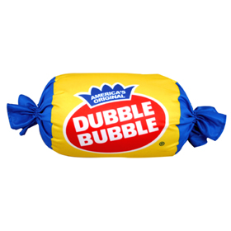
Name___________________________________________ Date________________ Period___________

Bubbles
Exploring the Scientific Method

Objective:
The purpose of this lab is to use the Scientific Method to solve a problem. Here are the steps:
A) Observe something (usually a phenomenon) and form a problem (usually a question)
B) Form a hypothesis (a prediction)
C) Test the hypothesis with a controlled experiment by making observations and gathering data.
D) Analyze gathered data
E) Reject or Accept your hypothesis
F) Form a conclusion

Materials:
2 small pieces of wax paper
1 meter long piece of string
1 meter stick
2 different pieces of bubble gum labeled A and B

READ directions carefully before starting the lab. Each group will need one piece of gum labeled A and one labeled B. Make 3 observations about each brand of gum.

Problem: Which piece of bubble gum blows the biggest bubble?

Procedure:
1. The person with brand A will chew their piece of gum for 3 minutes. The person with brand B does not begin chewing until all the tests on brand A are completed.

2. Blow a bubble.

3. Using a string, your partner will measure the diameter (distance across) the bubble. Put the string on the meter stick to measure the distance in centimeters (cm).
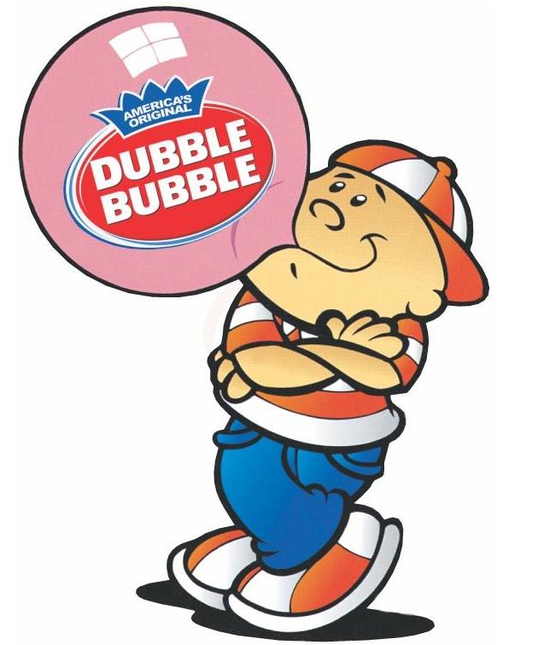
4. Record the measurement in a data table. Repeat the process for trials 2 and 3.

5. Find the average bubble size for brand A (add all the distances up and divide by 3) and put in the data chart.

6. Repeat steps 1-5 with brand B gum.

NAME___________________________________ DATE_____________________ PERIOD________________
BUBBLES DATA SHEET
Observations:
Gum A Gum B

1.____________________________ 1.___________________________
2.____________________________ 2.___________________________
3.____________________________ 3.___________________________
Hypothesis: Predict which piece of gum will blow the biggest bubble and why.
If____________________________________________________________________________________________
then_________________________________________________________________________________________
because______________________________________________________________________________________

Data Table:
Design a data collection table to fit the data you will be investigating

Conclusion:
Forming a theory
What brand of gum is the best at blowing bubbles and why? Support your answer with observations and your data.
_____________________________________________________________________________________________
_____________________________________________________________________________________________

PART 2

Combine with another group to complete this part of the lab.

Problem: How does gum strechability relate to bubble size?

Hypothesis: Make an educated guess that would answer the above question.

_____________________________________________________________________________________________

Procedure:
1. The person with brand A will roll their gum into a ball.

2. Hold the gum (brand A) by using the piece of wax paper. Another person in the group would hold the same piece of gum with another piece of wax paper. Hold the gum near your chest, begin to walk slowly backwards.

3. The third person in the group should hold the meter stick and measure the distance in centimeters the gum stretched before breaking.

4. Record the measurement in the data chart. ONLY DO ONE TRIAL

5. Repeat #1-4 for brand B gum.

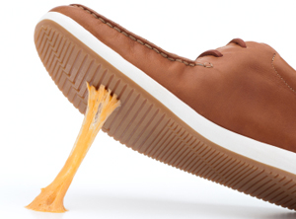
Data Table:
Create a data table to fit the data you will be gathering

Conclusion:
COMPARE DATA FROM BOTH GROUPS IN PART 1 AND PART 2

How does gum stretchability affect bubble size?

_____________________________________________________________________________________________

_____________________________________________________________________________________________

With your lab partner, list 5 variables that may affect the outcome of this experiment.

1. ____________________________________________________________________________

2. ____________________________________________________________________________

3. ____________________________________________________________________________

4. ____________________________________________________________________________

5. ____________________________________________________________________________

Explain how the data you collected can be described as both qualitative and quantitative
__________________________________________________________________________________________________________________________________________________________________________________________

Were SI units used in this lab? Explain. __________________________________________________________
_____________________________________________________________________________________________

List any questions you still have about the scientific method.
_____________________________________________________________________________________________

