Teacher: Mrs. Chow | Phone/voicemail: 707-693-6330 x 7212
Textbook: Holt’s Modern Earth Science, Ed. 2 | Email:
Website: www.mchow.weebly.com | Conference time: M, T, W & F Lunch or after school if scheduled with advanced notice
Dixon High School
Earth & Physical Science
Course Syllabus, 2012-2013

Purpose: This course is designed to provide students the opportunity to focus on various aspects of Earth’s composition and external and internal forces that affect its topography and structure. Students will utilize technology, laboratory experiences, and problem solving opportunities to enhance science understanding and application of scientific reasoning. Independent research and preparation may be expected of all students enrolled in this course.

Major Instructional Goals:
• Apply concepts of scientific inquiry
• Demonstrate an understanding of technology, development theories, and human endeavors
• Apply the properties and principles of matter and energy
• Apply knowledge of Earth’s structure and processes that affect human activity today

Grading: Points are assigned to four categories; 25% quizzes/tests (including essential standards assessments), 25% labs & projects, 40% work in class, 10% final exam

Grading Scale (%):
A 100 – 93 | B+ 87-89 | C+ 77-79 | D+ 67-69
A- 90-92 | B 83-86 | C 73-76 | D 63-66
 | B- 80-82 | C- 70-72 | D- 60-62

Academic Honesty: Plagiarism or cheating of any kind will result in a zero for that assignment, test, quiz, or lab. This involves the use of notes, books, past assignments, tests, or quizzes, or the use of another student. The principal will be also be notified as well as a parent and further action may be sought. Refer to the student handbook for any other questions concerning academic honesty.

Materials: Please be responsible and bring your own supplies. These include a 3 ring binder, loose-leaf paper, scientific calculator, pencils, pens and colored pencils (highly recommended). If you have extenuating circumstances that prevent you from attaining these materials please contact me.

Class Expectations:
1. Students must follow the safety guidelines outlined in the safety contract and all rules listed in the Student Handbook.
2. Cell phones are not to be seen or heard, you can only use them between class, during lunch and before and after school. There is a new and strictly enforced electronics policy. Please see Student handbook.
3. Inappropriate use of computers, lab equipment, and chemicals is prohibited.
4. Voices are to be kept at a quiet level during class and labs.
5. Food and all drinks with the exception of water are prohibited.
6. Daily directions must be followed to ensure the safety of all students.

Labs: Horseplay in the lab is dangerous and will not be tolerated. All labs may be completed with a partner unless otherwise directed. However, each student is responsible for his or her own lab write-up. This means you do NOT make a copy of your partner’s lab or allow your partner to copy yours. Data collection, calculations, analysis, and questions are an individual effort. If you miss a lab you must make up the points for the lab. Make-ups for labs typically need to be done within two to three days of the lab. However, this means that I will decide if you need to make up the lab before or after school. I may instead choose for you to do an alternative assignment worth the same number of points as the lab to make it up.

Attendance & Missing Work: Attendance and absence procedures are listed in the student handbook.

Attendance Procedures:
• Parents should notify the attendance office each day the student is absent. Student not excused from school by parent/guardian will be considered truant. Work missed because of truancy may not be completed for credit.
• Homework and make up work guidelines- it’s the student’s responsibility to check with the teacher(s) as to work missed during the absence and procedure to follow. Should the student choose not to contact the teacher(s) within five school days and make arrangements for work missed, the teacher is absolved of any responsibility for the student’s negligence in this matter and will record a grade of “F/0” for each of the assignments missed during the absence.

Class warm up exercises: At the beginning of some classes there will be a set of questions on the overhead projector, written on the board, or LCD screen. These questions could be over material covered in the previous class, material to be covered in that day’s class, procedures in the lab, a set of mathematical calculations, an open book quiz, a closed book quiz, definitions, opinions, or questions designed to get you to “think outside of the box”. It is to be done BY YOURSELF. These questions are due within the first 5-10 minutes of the start of the class; so get to class, find your seat, and get to work. If you are not in class you will be responsible for getting the questions and answers from another student. I will collect your warm up sheets periodically for grading.

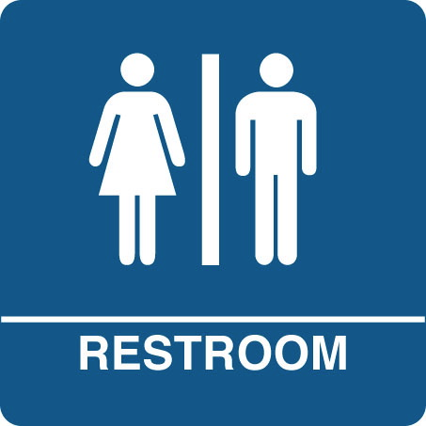
Tests: Tests will be taken in class on the day assigned. If you know that you will be absent due to school excused, athletic, or medical absence, you must take the test PRIOR to your absence. Unless you are in the hospital or have contracted a rare disease, I expect to see you in class (if you are actually very ill, you will take the test when you return to school). The Final Exam will be comprehensive in nature (covers all material during the semester) and will be worth 10% of your class grade.

Restroom passes: Are for emergencies only. Use the restroom before class begins as much as possible.

Assignments: ALL assignments are due on time. I do not accept late homework. Assignments are due at the beginning of the class period on the date assigned. Procedures and policies for make-up work due to an absence are listed in the student handbook.

Participation: Participation in the class will be noted throughout the semester. Lack of participation includes tardies, unexcused absences, behavioral problems, failure to participation in class discussions or activities, or any other events that distract from learning or participation in classroom activity.
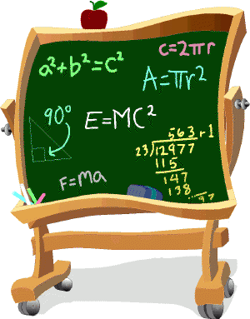
Tutoring: DO NOT hesitate to ask for help. I will do my best to get you the help you need. If you are struggling and need extra help, I am available before or after school and during my free period. There is no excuse for not taking advantage of my donated time.

Special Needs: If you have any medical conditions WHAT-SO-EVER that I should be aware of because they could affect your performance in this class please tell me. If you have poor sight, poor hearing, allergies, seizures, a learning disability, or some other condition please inform me at the beginning of the semester that way I am aware of the situation and can suite your needs to the best of my ability.

Behavior: You are quickly approaching adulthood, and adult behaviors will be expected of you. I expect that you not talk while I am talking and I will refrain from talking when you are talking. Inappropriate language, notes to friends, drawing, throwing of objects, tampering with chemicals or other equipment, or other inexcusable actions will be dealt with and will depend on the offense. Class time is the time where you are in my class to learn about science. If you are using these behaviors in class you are wasting my time and the time of others in the class. Please take this as seriously as I do.

Emergency Procedures:
Refer to the Emergency Management Plan notebook or student handbook. Emergency procedures will also be posted in the classroom.

----------------------------------------------CUT AND RETURN TO MRS. CHOW---------------------------------------------------

Course: Earth & Physical Science
Student Name (printed please) ________________________ Period _________

I have read and understand this Integrated Science syllabus, including all sections provided.

_____________________________
Student Signature Date

_____________________________
Parent Signature Date

Home Number: _____________________________ Work Number: _____________________________

Email Address: _____________________________ Cell Phone: _____________________________

Please circle preferred method of communication.

Any questions? Please contact me via email or phone after 3PM M-F.

